**Chapter 1:**

**• Elements of an Organization’s Culture**1.1 Organization History  
1.2 Type of Business  
1.3 Management Style

**• Communicating Internationally**2.1 Simplify Grammar and Style Rules  
2.2 Use Simple Verb Tenses and Constructions  
2.3 Limit Vocabulary to Clear Words  
2.4 Use Consistent Language and Terminology  
2.5 Define Technical Terms  
2.6 Avoid Slang Terms and Idioms  
2.7 Include Visuals

**• Ethics Guidelines**3.1 Be Honest  
3.2 Do No Harm  
3.3 Be Fair  
3.4 Honor Intellectual Property Rights  
3.5 Respect Confidentiality  
3.6 Be Professional

**• Ethics and Legal Issues in Writing**4.1 Legal Issues in Writing  
4.1.1 Acknowledge Sources for Information Other Than Common Knowledge  
4.1.2 Seek Written Permission Before Borrowing Extensive Text  
4.1.3 Seek Written Permission Before Borrowing Graphics  
4.1.4 Seek Legal Advice for Complex Questions

**Chapter 6:**

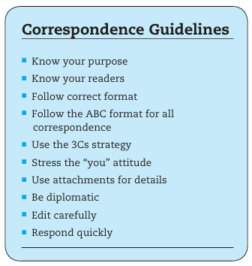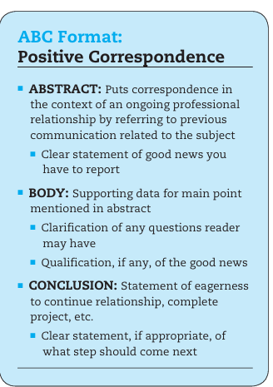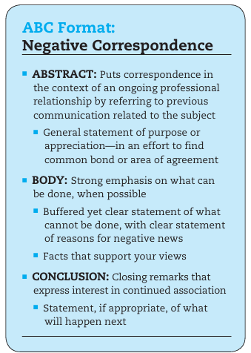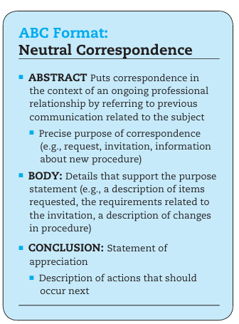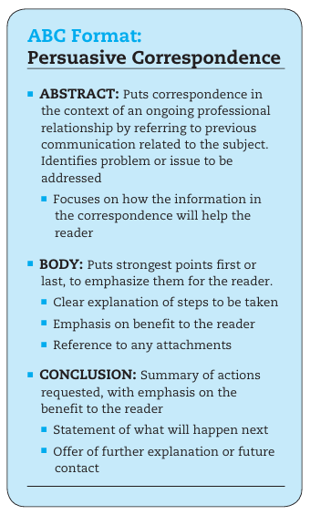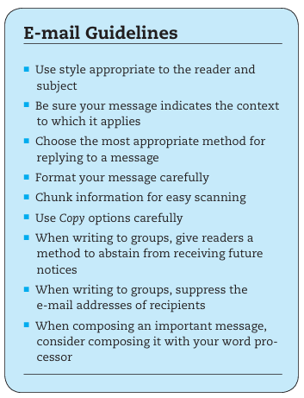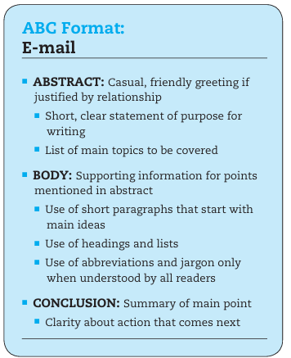

Use the 3Cs Strategy: Capture, Convince, Contact

**Chapter 9:**

**• Reviewing Published Research**

* Secondary Sources
  1. Author or Title Search
  2. Subject Search
  3. Keyword Search
  4. Advanced Search Techniques
  5. Boolean Search
  6. Positional Operators
  7. Truncation

**• Searching Online Catalogs**

* Fundamentals of Searching
* Searching by URL
* Searching by Keywords Using Search Engines and Meta-Search Engines

**• Library Resources**

1. Books
2. Periodicals
   * Popular Magazines
   * Professional and Scholarly Journals
3. Newspapers
4. Company Directories
5. Dictionaries, Encyclopedias, and Other General References

**• Searching the Web**

* Fundamentals of Web Searching
* Web Search Options
  + URL Search
  + Index-Type Search Engine
  + Subject Directory
  + Guides to Reviewed and Recommended Websites

**• Evaluating Sources**

* Obscured Authorship
* Out-of-Date Information
* Subtle and Obvious Bias
* Poor-Quality Links
* Flawed Style and Design

**• Conducting Primary Research**

* Quantitative Research
  + Validity
  + Reliability
* Qualitative Research
  + Interviews
  + Focus Groups
  + Field Observations
  + Document Analysis

**• Interview Process**

* Step 1: Preparing for the Interview
  + Develop a list of specific objectives for the interview.
  + Make clear your main objectives when you make contact for the inter view.
  + Prepare an interview outline.
  + Show that you value your interviewee’s time.
* Step 2: Conducting the Interview
  + Ask Open-Ended
  + Ask Close-Ended Questions when you need to nail down an answer.
  + Using Summaries throughout the interview.
* Step 3: Recording the Results
  + Number Reference
  + Combined Question-and-Answer Page
  + Split Page

**• Using Surveys**

* Step 1: Preparing the Survey
  + Write a precise purpose statement.
  + Limiting Questions
  + Ask Objective Questions
    - Either/Or Questions
    - Multiple-Choice Questions
    - Graded-Scale Questions
    - Short-Answer Questions
  + Provide clear questions that are easy to answer.
    - Biased question:
    - Undefined technical terms:
    - Mixed variables:
    - Question that requires too much homework:
  + Include precise and concise instructions at the top of the form.
  + Apply principles of document design.
  + Test the survey on a sample audience.

**• Step 2: Conducting the Project**

* Choosing an Appropriate Audience
* Introducing the Survey with a Cover Letter
  + Opening Paragraph: Clearly state the purpose of the survey and why the reader was selected.
  + Middle Paragraph(s): Emphasize the importance of the project and highlight benefits to the reader.
  + Concluding Paragraph: Specify the return deadline for the survey.
* Encouraging a Quick Response

**• Step 3: Reporting the Results**

**Usability Testing**

**• Using Borrowed Information Correctly**

* Avoiding Plagiarism
  + Three Reasons for Documenting Sources:
    1. Courtesy: Allows readers to find additional information on the subject.
    2. Ethics: Clearly distinguish between your ideas and borrowed ideas.
    3. Law: Prevent legal violations.
* The Methodical Process for Documentation
  + Bibliography Notes
  + Rough Outline
  + Notes (Three Main Types)
  + Final Outline
  + Drafts

**• Selecting and Following a Documentation System**

* APA (American Psychological Association)
* CSE (Council of Science Editors)
* MLA (Modern Language Association)
* University of Chicago Press (Turabian and Chicago Manual of Style)
* Purdue Online Writing Lab
* University of Wisconsin’s Writing Center

**• Reporting Your Research**

* ABC Format for Technical Research
* Writing Research Abstracts
  + Types of Abstracts:
    - Informational Abstracts
      * Format: Includes major points.
      * Purpose: Offers enough detail to grasp findings, conclusions, and recommendations.
      * Length: Typically one to three paragraphs.
      * Example: A detailed explanation of functional résumés.
    - Descriptive Abstracts
      * Format: Lists only main topics.
      * Purpose: Helps readers decide if they want to read the full document.
      * Length: Typically one paragraph.
      * Example: High-level summary without conclusions.
* Guidelines for Writing Research Abstracts:
  + **Highlight the Main Points.**
  + **Sketch an Outline.**
  + **Begin with a Short Purpose Statement.**
  + **Maintain a Fluid Style.**
  + **Avoid Technical Terms Unfamiliar to the Reader.**

**Chapter 10:**

**1. Create the Abstract as an Introductory Summary**

* Purpose
* Scope
* Summary

**2.Put Important Details in the Body**

* Use headings generously.
* Precede subheadings with a lead-in passage.
* Move from general to specific in paragraphs.

**3.Separate Fact From Opinion**

* Findings
* Conclusions
* Recommendations

**4.Use Attachments for Less Important Details**

* Tables and figures
* Costs

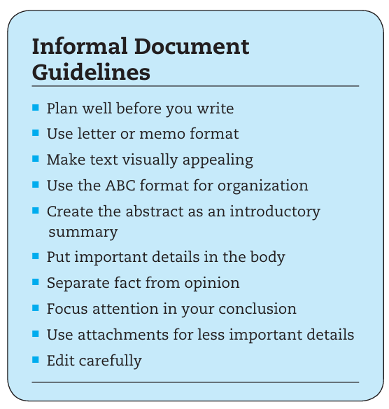

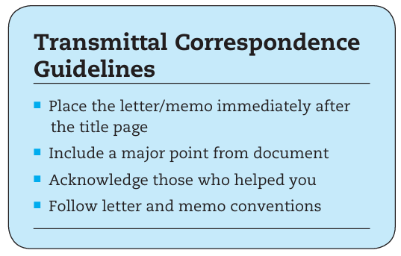

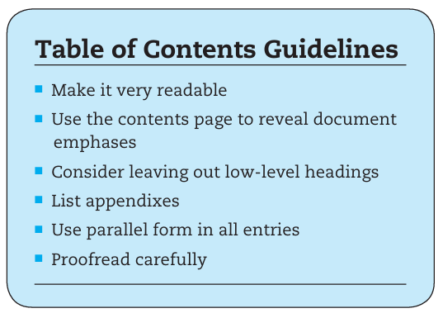

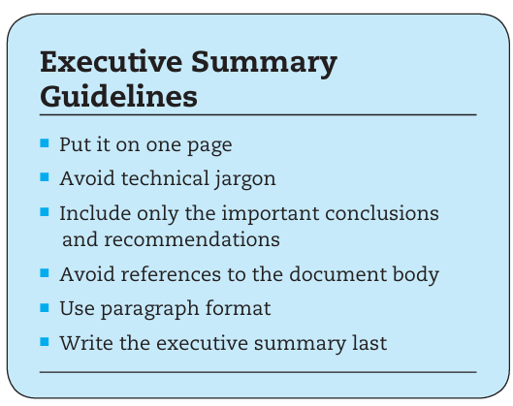

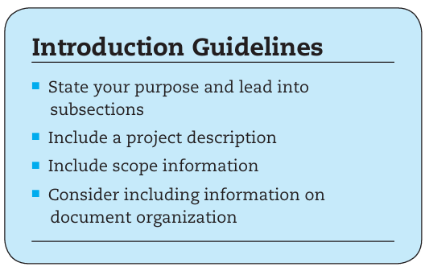

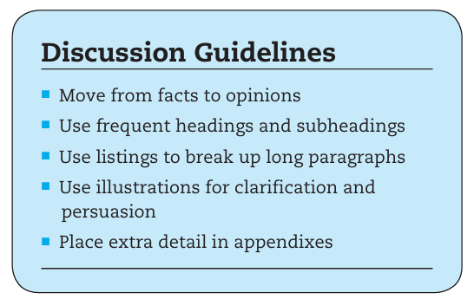

**Chapter 11:**

**1. Common Informative Reports**

1.1 Activity Reports  
1.2 Incident Reports  
1.3 Progress Reports  
1.4 Regulatory Reports  
1.5 Lab Reports

**2. Common Analytical Reports**

**2.1 Technical Criteria**  
    2.1.1 Expertise and Capacity  
    2.1.2 Physical Space for Change  
    2.1.3 Long-term Needs for Flexibility and Upgrades

**2.2 Managerial Criteria**  
    2.2.1 Financial Impacts  
    2.2.2 Personnel Costs for Hiring and Training

**2.3 Social Criteria**  
    2.3.1 Impact on Employees  
    2.3.2 Safety Considerations for Employees, Customers, and Environment  
    2.3.3 Consistency with Organizational Culture and Ethics

2.4 Problem Analyses  
2.5 Recommendation Reports  
2.6 Feasibility Studies  
2.7 Equipment Evaluations

**Chapter 12:**

**Unsolicited Proposals**

1 . Description of problem or project and its significance.

2. Proposed solution or approach.

3. Personnel.

4. Schedule.

5. Costs.

**Solicited Proposal**

Title Page

Letter/Memo of Transmittal

Executive Summary

Appendixes

**Formal sales proposals traditionally contain three basic types of information**

1 . Technical sections

2 . Management sections

3 . Cost section

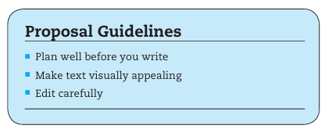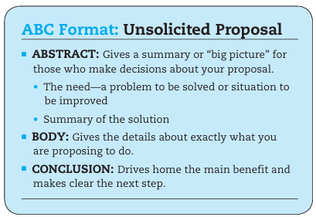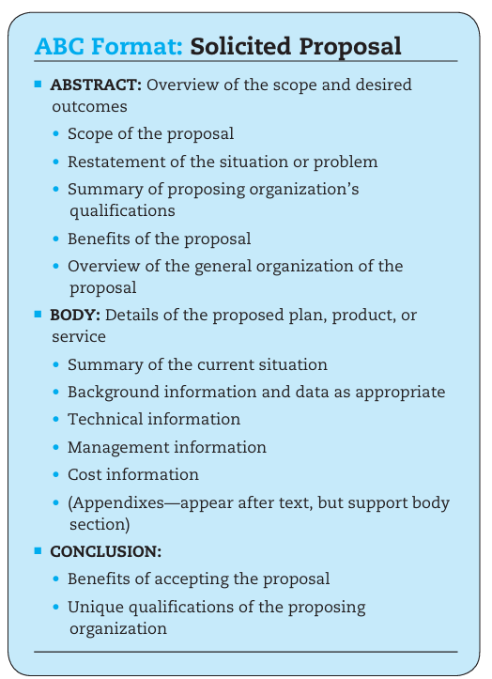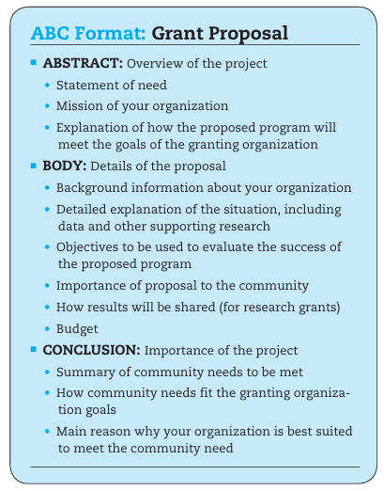

**Chapter 15:**

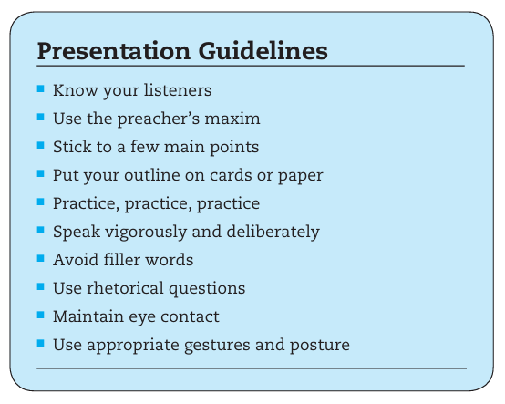

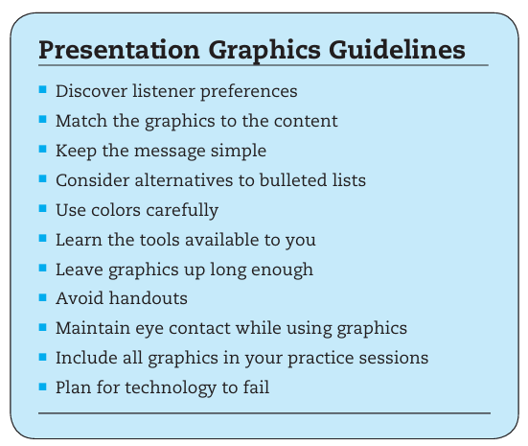

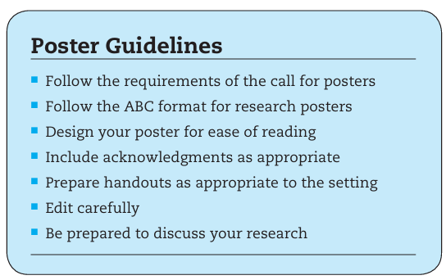

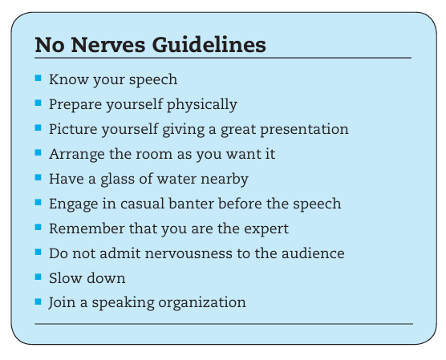

**Chapter 16:**

**Table of Contents**

1. **Build a Network of Professionals in Your Field**
   * 1.1 Casual Networks
   * 1.2 Professional Networks
   * 1.3 Online Networks
2. **Interview Someone in Your Field of Interest**
3. **Find Information on Companies in Your Field**
4. **Do Intensive Research on a Selected List of Potential Employers**
   * 4.1 Annual Reports
   * 4.2 Web Sites or Media Kits
   * 4.3 Personnel Manuals and Other Policy Guidelines
   * 4.4 Graduates of Your College or University Now Working for the Firm
   * 4.5 Company Newsletters and In-House Magazines
   * 4.6 Business Sections of Newspapers and Magazines
   * 4.7 Professional Organizations or Associations
   * 4.8 Stock Reports
   * 4.9 Accrediting Agencies or Organizations
   * 4.10 Former Employees of the Company
   * 4.11 Current Employees of the Company
5. **Use Your Computer to Gather Data**

Job Correspondence

5.1.1 Job Letters

* + - * 5.1.1.1 The Readers' Needs
        + Feature 1: They Read Job Letters in Stacks
        + Feature 2: They Are Impatient
        + Feature 3: They Are Tired
        + Feature 4: They Become Picky Grammarians
        + Feature 5: They Want Attention Grabbers but Not Slickness
    - 5.1.2 The Letter's Organization
  + 5.2 Résumés
    - 5.2.1 Emphasis
    - 5.2.2 Length
    - 5.2.3 Arrangement
  + 5.3 Types of Résumés
    - 5.3.1 Chronological Résumé
    - 5.3.2 Functional Résumé
    - 5.3.3 Combined Résumé

1. **Objective**
   * 6.1 Education
     + 6.1.1 Grade Point Average
     + 6.1.2 Honors
     + 6.1.3 Minors
   * 6.2 Experience
     + 6.2.1 Key Courses
   * 6.3 Activities, Recognitions, and Interests
     + 6.3.1 Activities
     + 6.3.2 Recognitions
     + 6.3.3 Interests
2. **Job Interviews Preparation**
   * 7.1 Do Your Homework on the Organization
   * 7.2 Prepare Portfolio Materials, If Appropriate for the Position
     + 7.2.1 Project Description
     + 7.2.2 Audience
     + 7.2.3 Skills
   * 7.3 Write Out Answers to the Questions You Consider Likely
     + 7.3.1 Tell me a little about yourself.
     + 7.3.2 Why did you choose your college or university?
     + 7.3.3 What are your strengths?
     + 7.3.4 What are your weaknesses?
     + 7.3.5 Why do you think you would fit into this company?
     + 7.3.6 What jobs have you held?
     + 7.3.7 What are your long-term goals?
     + 7.3.8 What salary range are you considering?
     + 7.3.9 Do you like working in teams or prefer working alone?
     + 7.3.10 Do you have any questions of me?
   * 7.4 Do Mock Interviews
   * 7.5 Be Physically Prepared for the Interview
     + 7.5.1 Dress Appropriately
     + 7.5.2 Take an Assertive Approach
     + 7.5.3 Use the First Few Minutes to Set the Tone
     + 7.5.4 Maintain Eye Contact While You Speak
     + 7.5.5 Be Specific in the Body of the Interview
     + 7.5.6 Do Not Hesitate
     + 7.5.7 Reinforce Main Points
3. **Follow-up Letters**
   * 8.1 Importance of Follow-up Letters
   * 8.2 Structure and Guidelines for Writing a Follow-up Letter